**BREAST CANCER DETECTION USING NI LABVIEW AND VISION ASSISTANT TOOL**

**ABSTRACT**

Globally, 685 000 persons passed away in 2020, and 2.3 million women received a breast cancer diagnosis. By the end of 2020, 7.8 million women who had been diagnosed with breast cancer in the preceding five years were still alive. The epithelial lining of the glandular tissue's ducts (85%) or lobules (15%) is where breast cancer first appears. The cancerous growth is initially restricted to the duct or lobule ("in situ"), where it frequently exhibits no symptoms and has a minimal chance of dispersing (metastasis). This paper will employ NI Labview technologies to detect breast cancer.

**METHODOLOGY**

* **Aanalaysing**

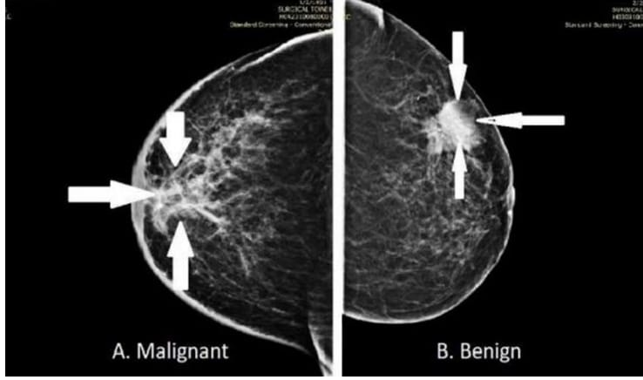

* **Analysing size, shape, position, angle and length of the tumor**
* **Calibration of image**
* **Edge detection**
* **Histogram analysis**
* **Colour contrasting**
* **Image masking**

**INTRODUCTION**

When the cells in the breast proliferate uncontrollably, it results in breast cancer. Breast cancer can manifest in several ways. Breast cancer can take many different forms, depending on which breast cells became cancerous.

Breast cancer can develop in the breast in a variety of places. A breast's three main parts are lobules, ducts, and connective tissue. Lobules are the name for glands that produce milk. Ducts are the tubes that carry milk to the nipple. The majority of breast tumors begin in the ducts or lobules, which are covered with connective tissue and hold all the components together. Breast cancer can spread outside the breast through lymphatic and blood vessels. "Metastasized" describes breast cancer that has spread to other parts of the body.

**Fig. 1 Representation of malignant and benign tumor mammogram**

**TYPES OF BREAST CANCER**

**Ductal or lobular carcinoma**

Carcinomas, or tumors that originate in the epithelial cells lining organs and tissues throughout the body, account for the majority of breast cancer cases. Adenocarcinomas, which originate in cells in the ducts (the milk ducts) or the lobules (the milk-producing glands in the breast), are typically the more specific type of carcinomas that form in the breast.

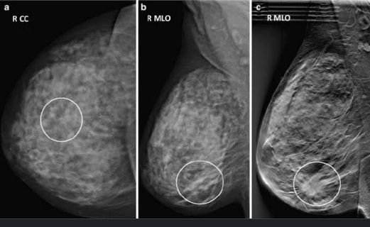

**Fig.2 Ductal or lobular carcinoma**

[**Invasive breast cancer (ILC or IDC)**](https://www.cancer.org/cancer/breast-cancer/about/types-of-breast-cancer/invasive-breast-cancer.html)

Invasive (or infiltrating) breast cancer has spread into surrounding breast tissue. The most common types are **invasive ductal carcinoma** and **invasive lobular carcinoma**. Invasive ductal carcinoma makes up about 70-80% of all breast cancers.

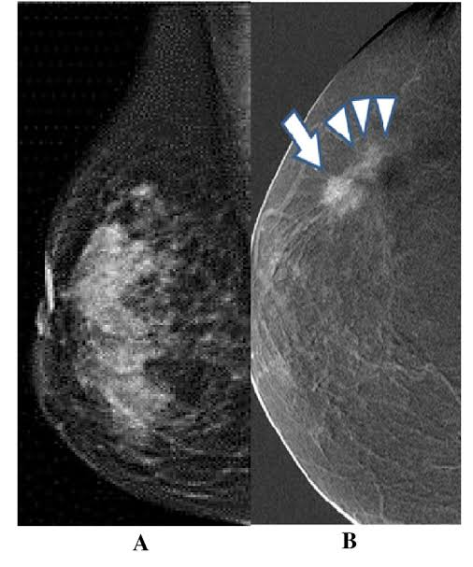

**Fig.3 Invasive breast cancer**

**Triple negative breast cancer**

Triple-negative breast cancer is an aggressive form of invasive breast cancer in which the cancer cells produce either too little or too much of the HER2 protein in addition to lacking ER or PR receptors. (All three tests return "negative" results for the cells.) It makes up 15% of all cases of breast cancer and can be challenging to treat.

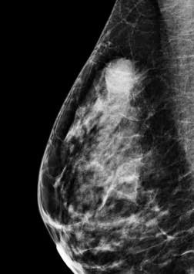

**Fig 4. Triple negative breast cancer**

### [**Inflammatory breast cancer**](https://www.cancer.org/cancer/breast-cancer/about/types-of-breast-cancer/inflammatory-breast-cancer.html)

An aggressive form of invasive breast cancer known as "inflammatory breast cancer" occurs when cancer cells obstruct skin lymph vessels, giving the appearance of a "inflamed" breast. It is extremely uncommon, making up 1% to 5% of all cases of breast cancer.

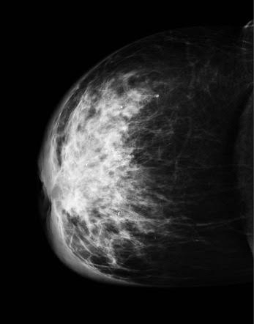

**Fig 5. Inflammatory breast cancer**

**NI LABVIEW AND VISION ASSITANT TUMOR ANALYSIS**

**1.HISTOGRAM**

Histogram—Counts the total number of pixels in each grayscale value

and graphs the result.

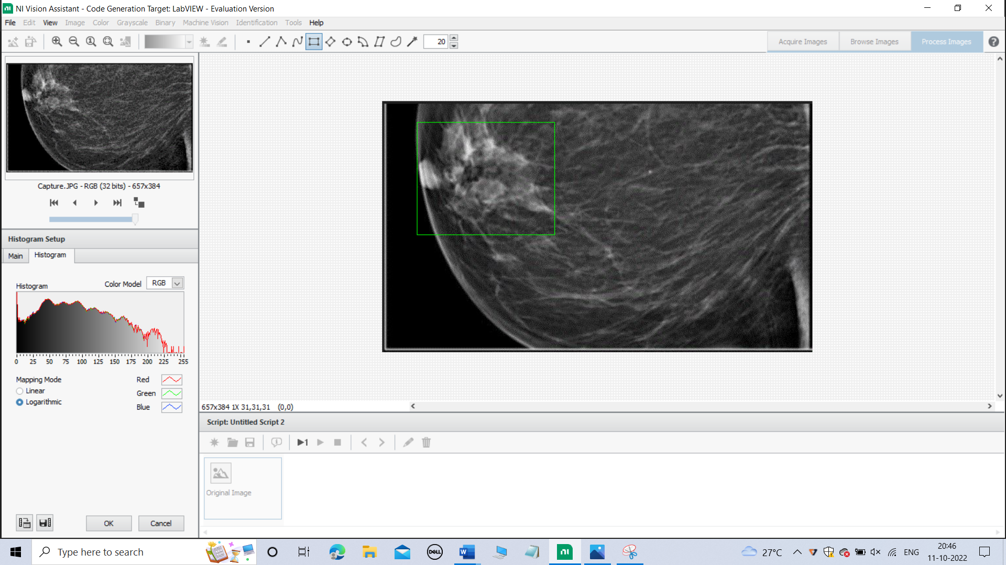 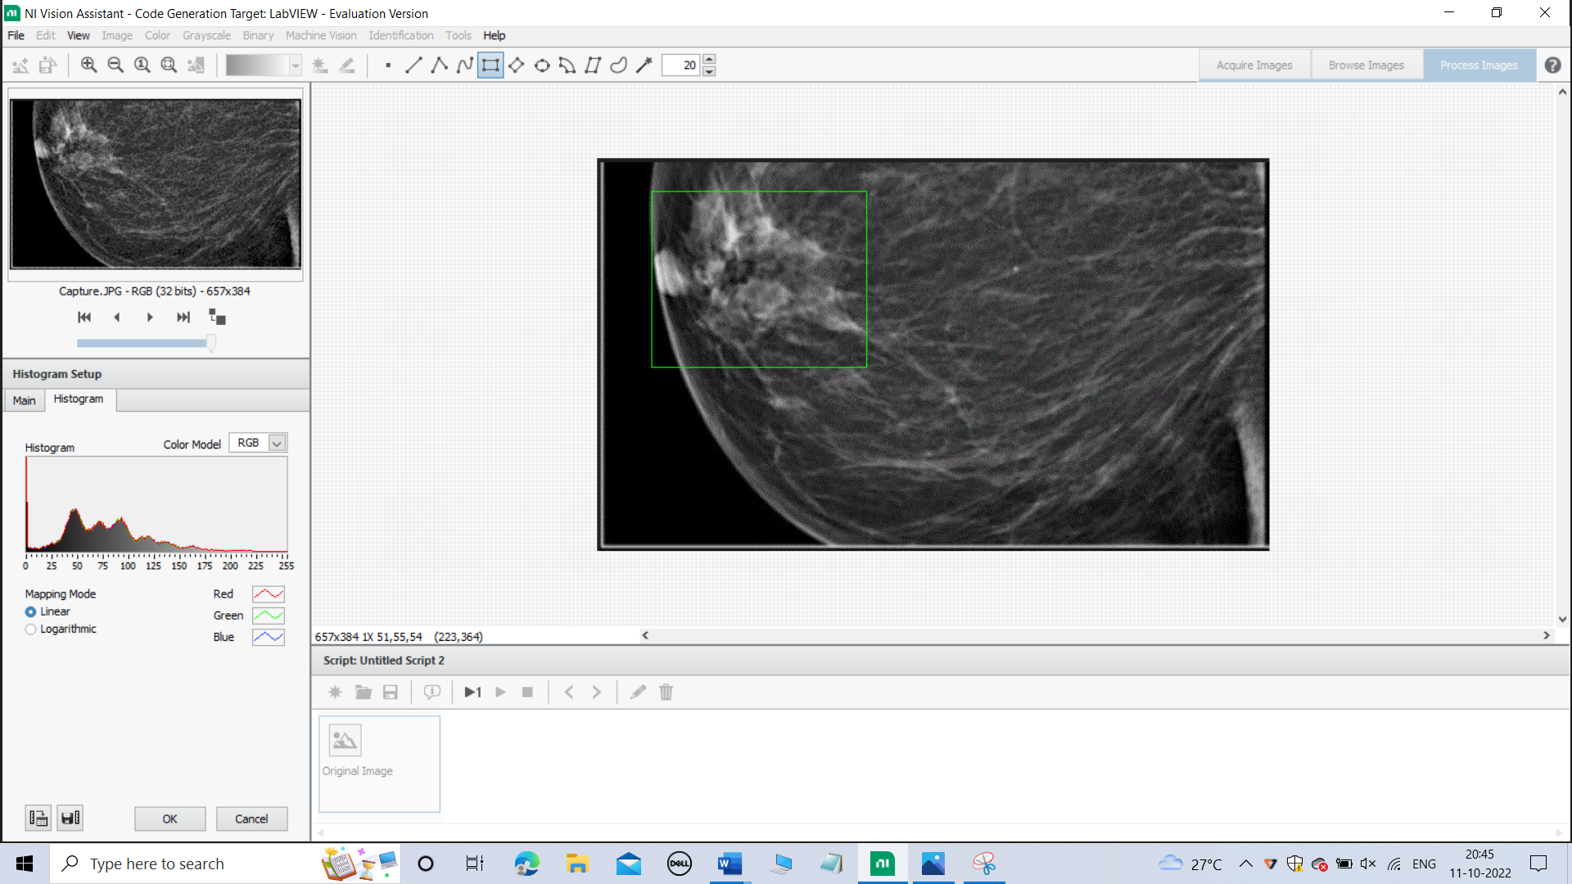

**Fig.6 Histogram analysis breast cancer detection**

**2.LINE PROFILE**

Line profile-Returns the grayscale values of the pixels along a line

that you draw with the Line Tool from the Tools palette and graphs the result. 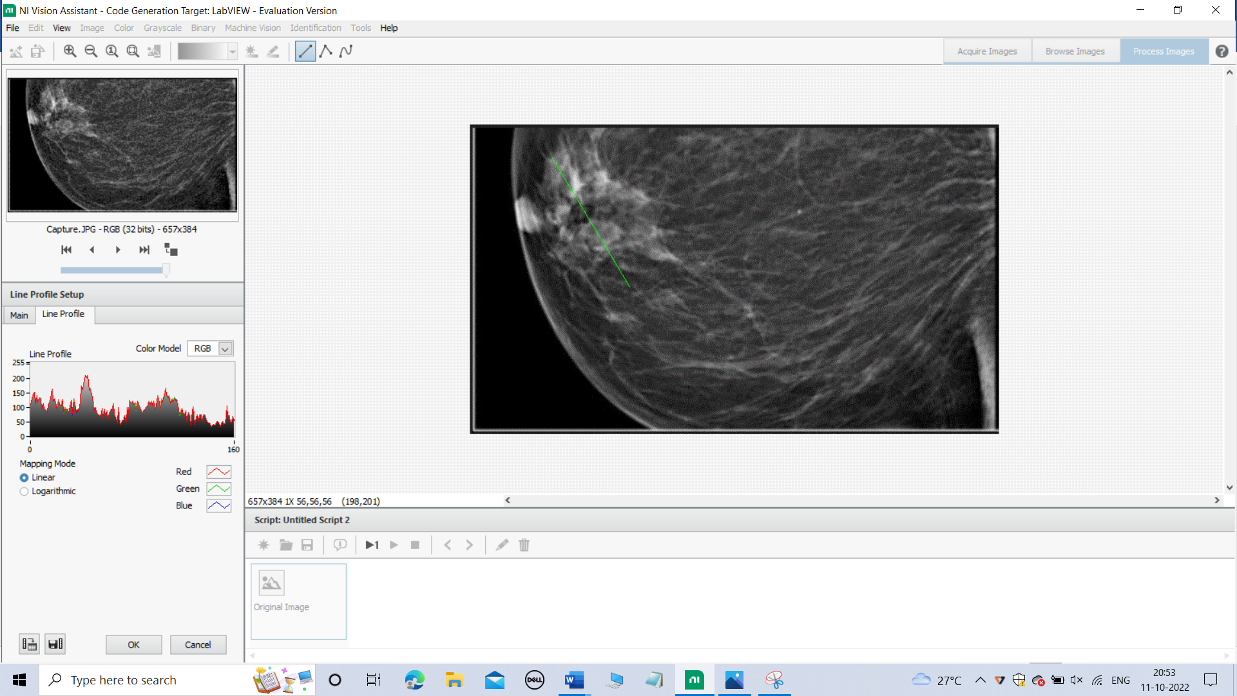

**Fig.7 Line profile analysis**

**3.** **MEASURE**

Calculates measurement statistics associated with a region

of interest in the image.

1. POSITION

To locate the position of the tumor

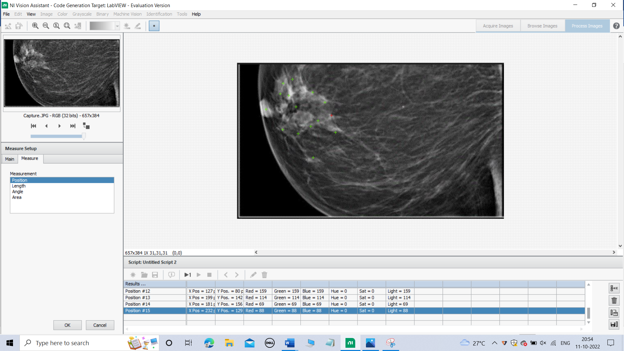

**Fig.8 Position analysis**

1. LENGTH

To measure the length of the tumor

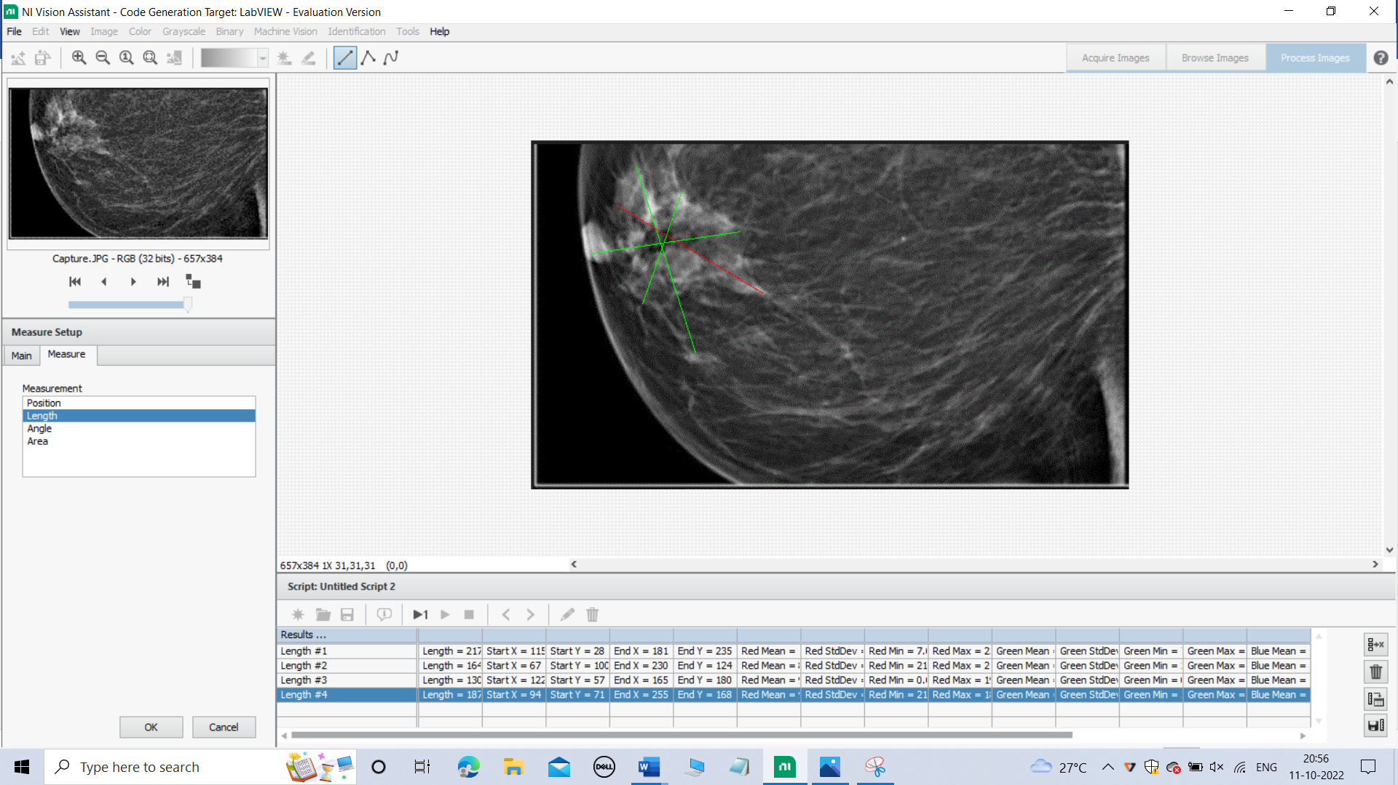

**Fig.9 Length analysis**

1. ANGLE

To measure the angle where the tumor located

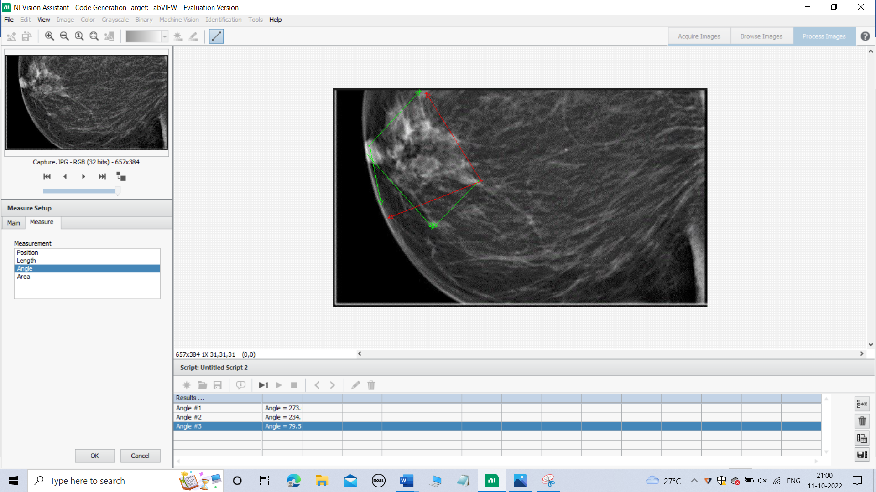

**Fig .10 Angle analysis**

1. AREA

To measure the area of tumor

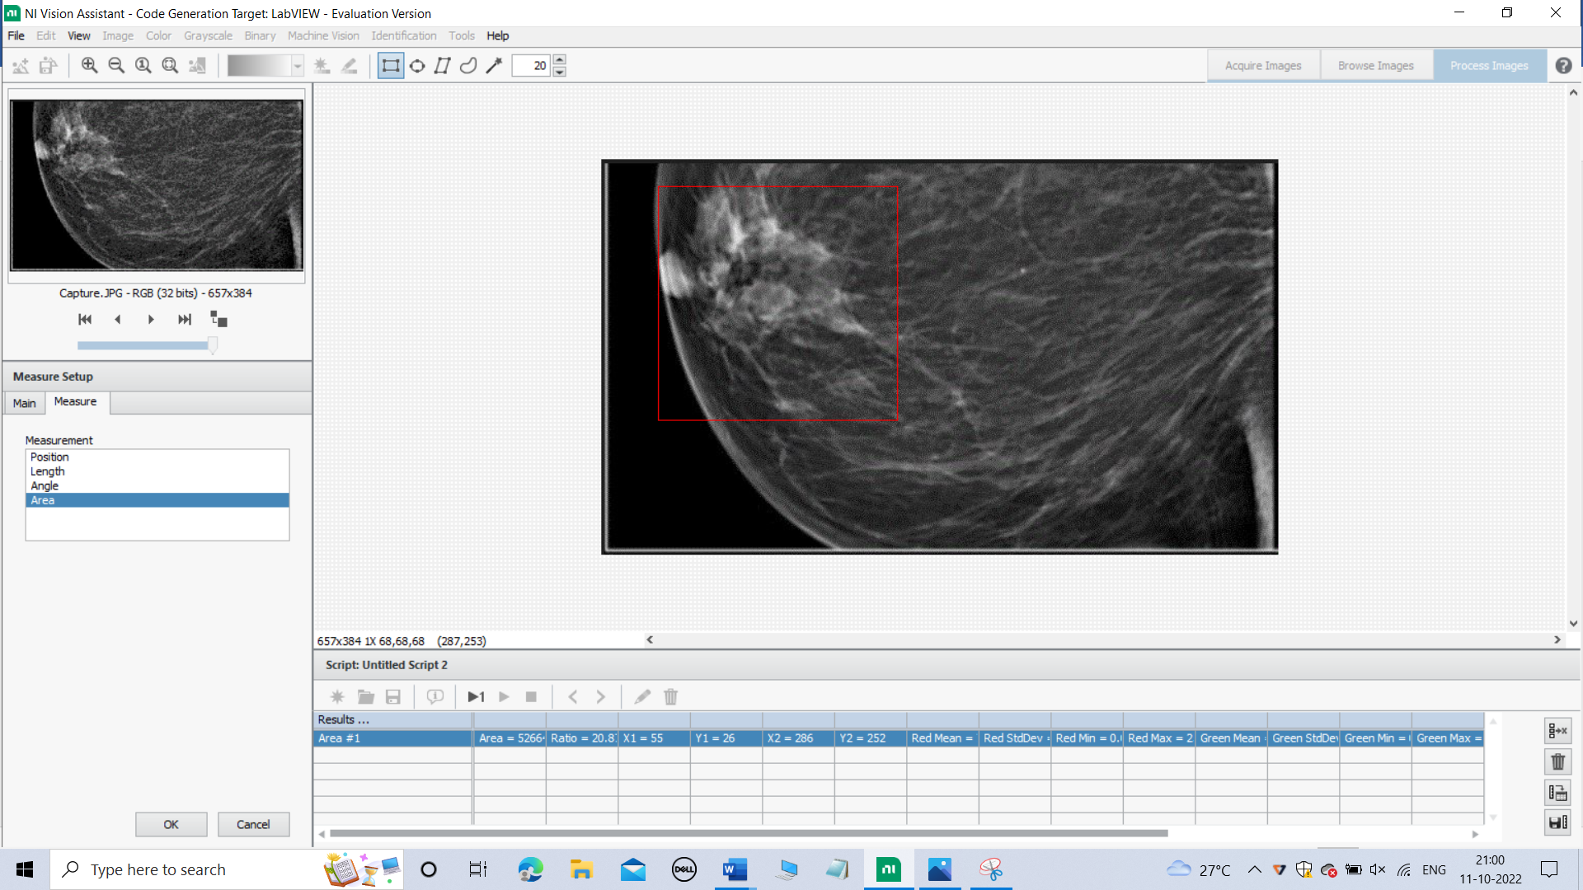

**Fig.11 Area analysis**

**4.BRIGHTNESS SETUP**

To differentiate the tumor from the mammogram

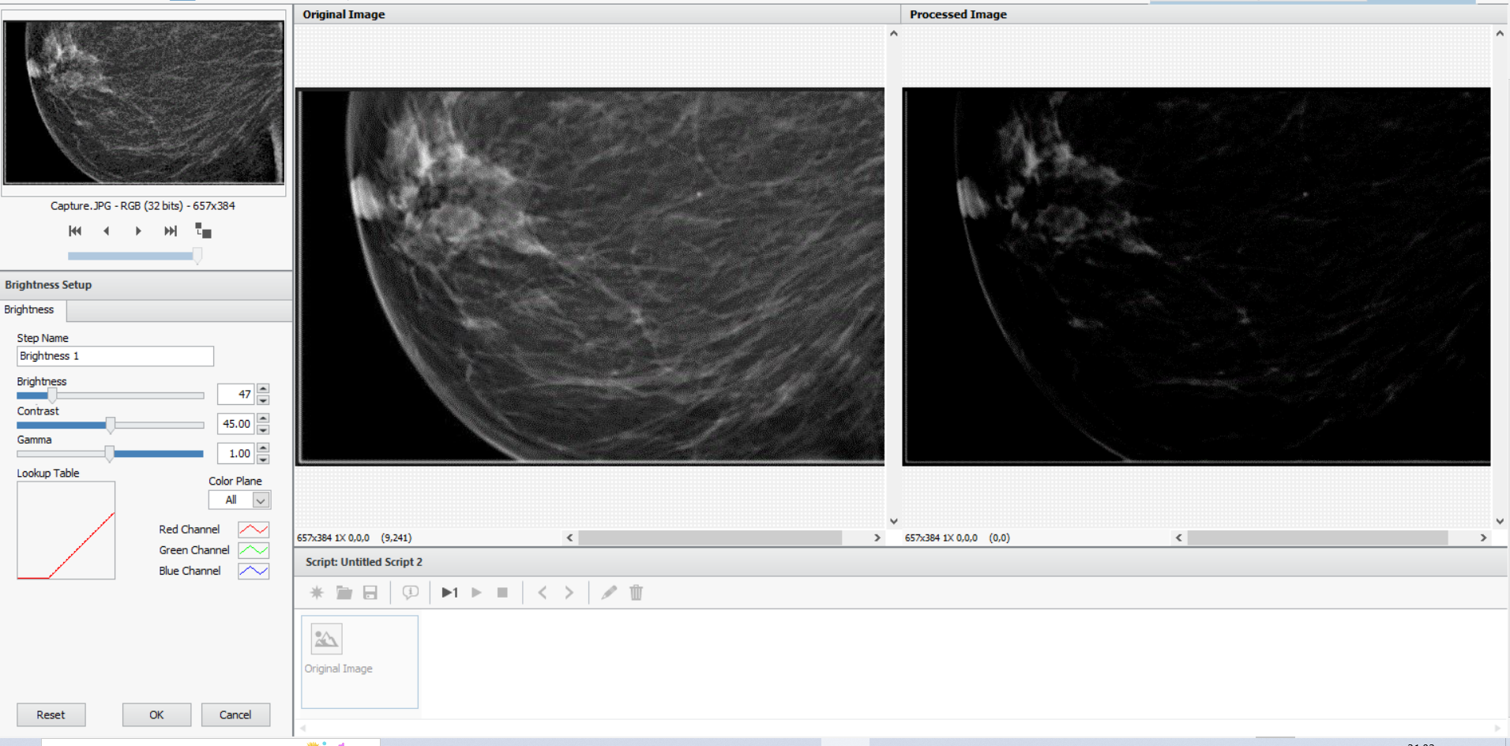

**Fig.12 Brightness and Contrast**

**4.IMAGE MASKING**

Image Mask—Builds a mask from an entire image or region of Interest.

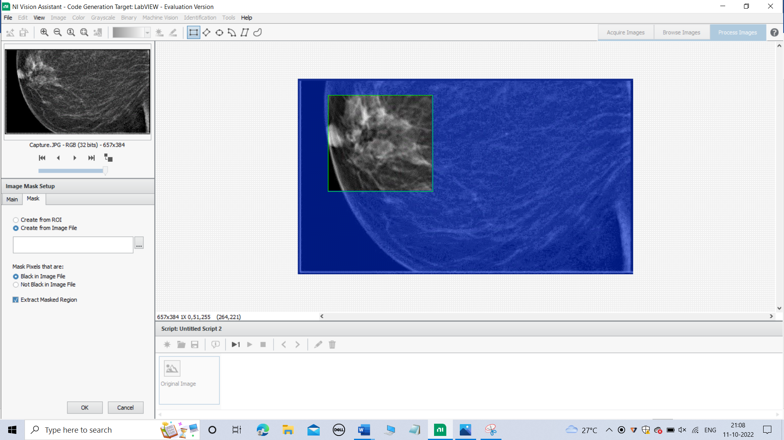

**Fig.13 Image masking**

**5.RESAMPLING**

To increase the resolution of the Region of Interest.

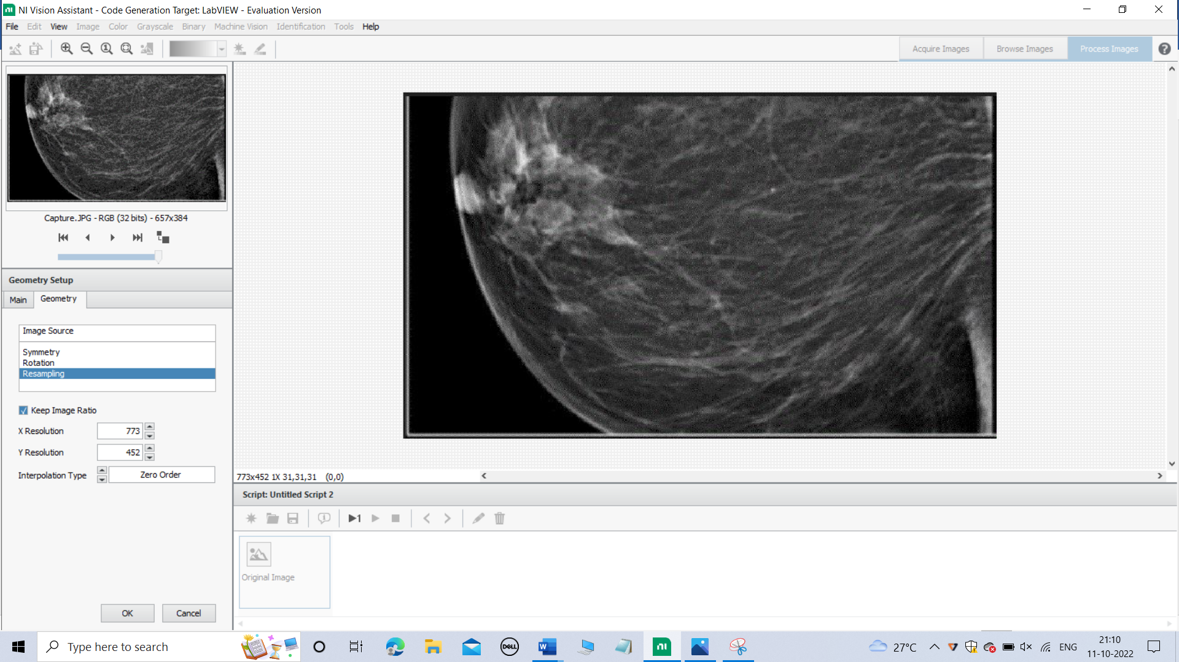

**Fig.14 Resampling of the image**

**6.IMAGE CALIBRATION:**

Calibrate from Image—Applies the calibration information saved in an

image to another image.

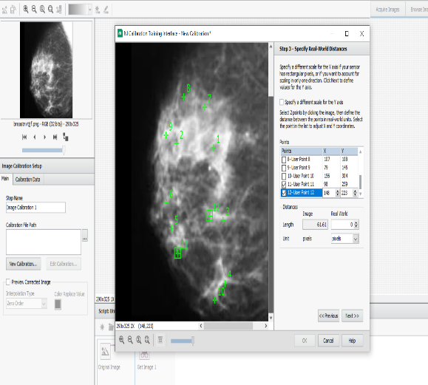 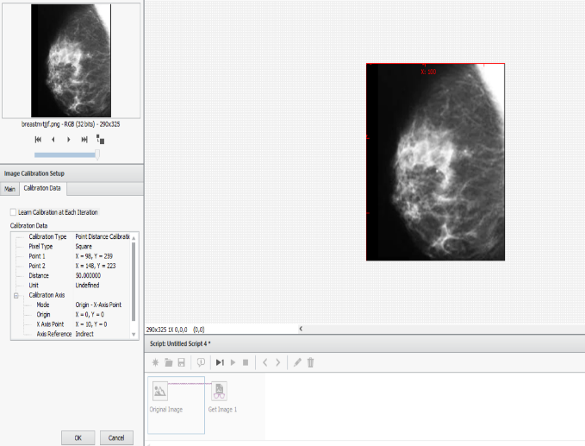

**Fig.15 Image calibration**

**7.EDGE DETECTION**

Edge detection techniques and tools that locate edges such as the rake, concentric rake, spoke, and caliper.

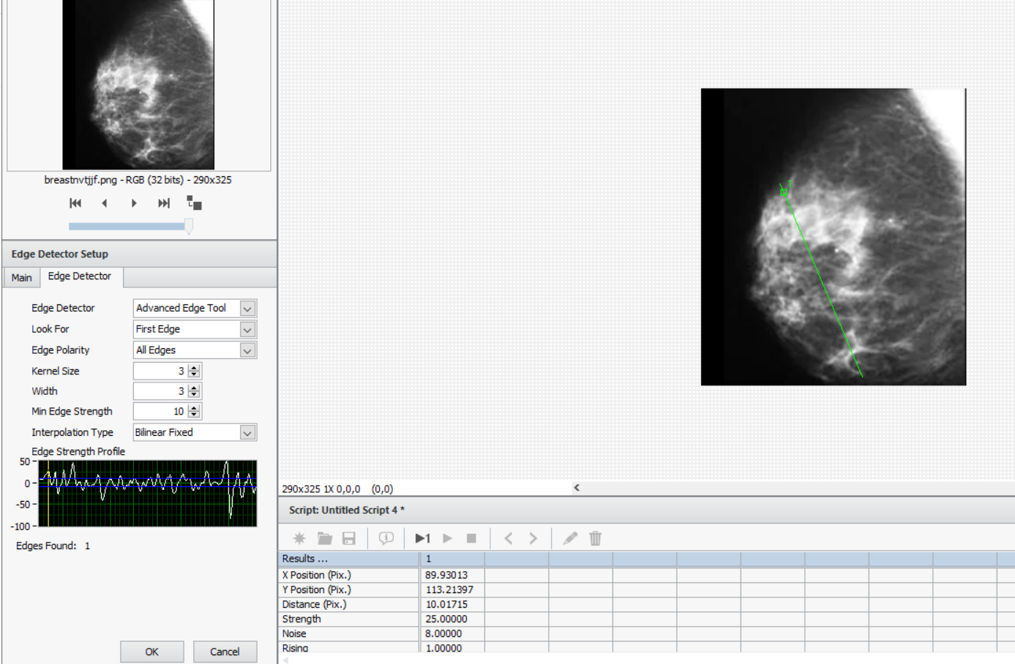

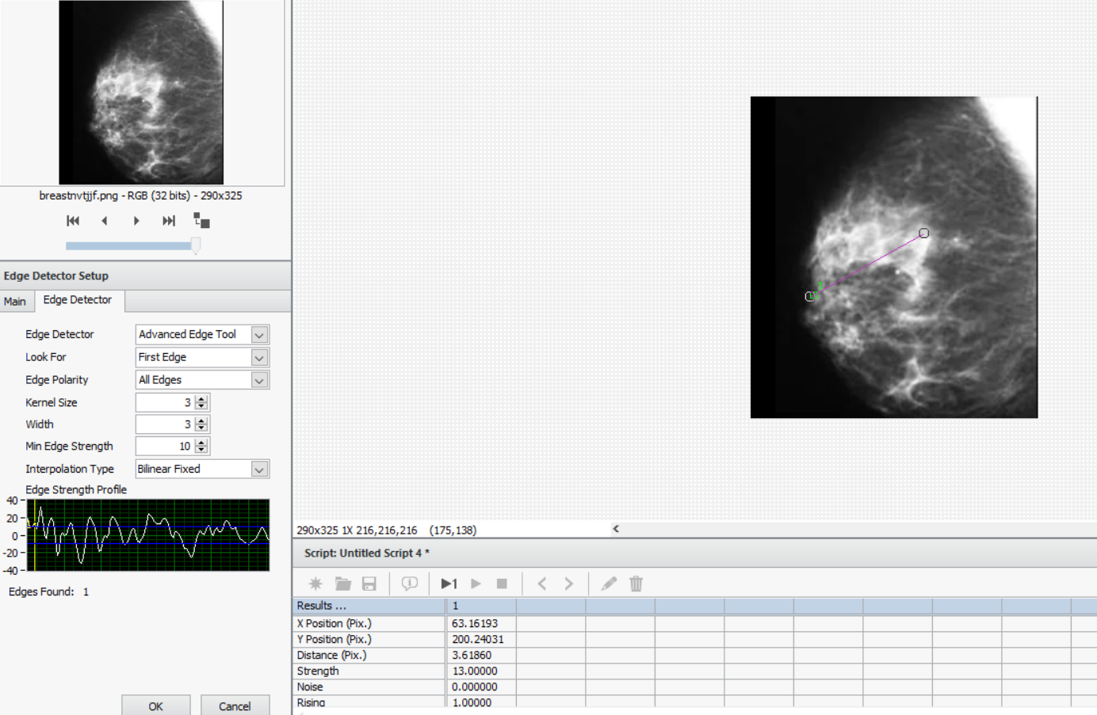

**Fig.16 Edge detection**

**8.FIND STRAIGHT EDGEE SETUP**

In a two-dimensional region of interest, the Find Straight Edge step looks for straight edges. The step looks for distinct transitions in pixel intensities along a number of search lines that are present in the region of interest. 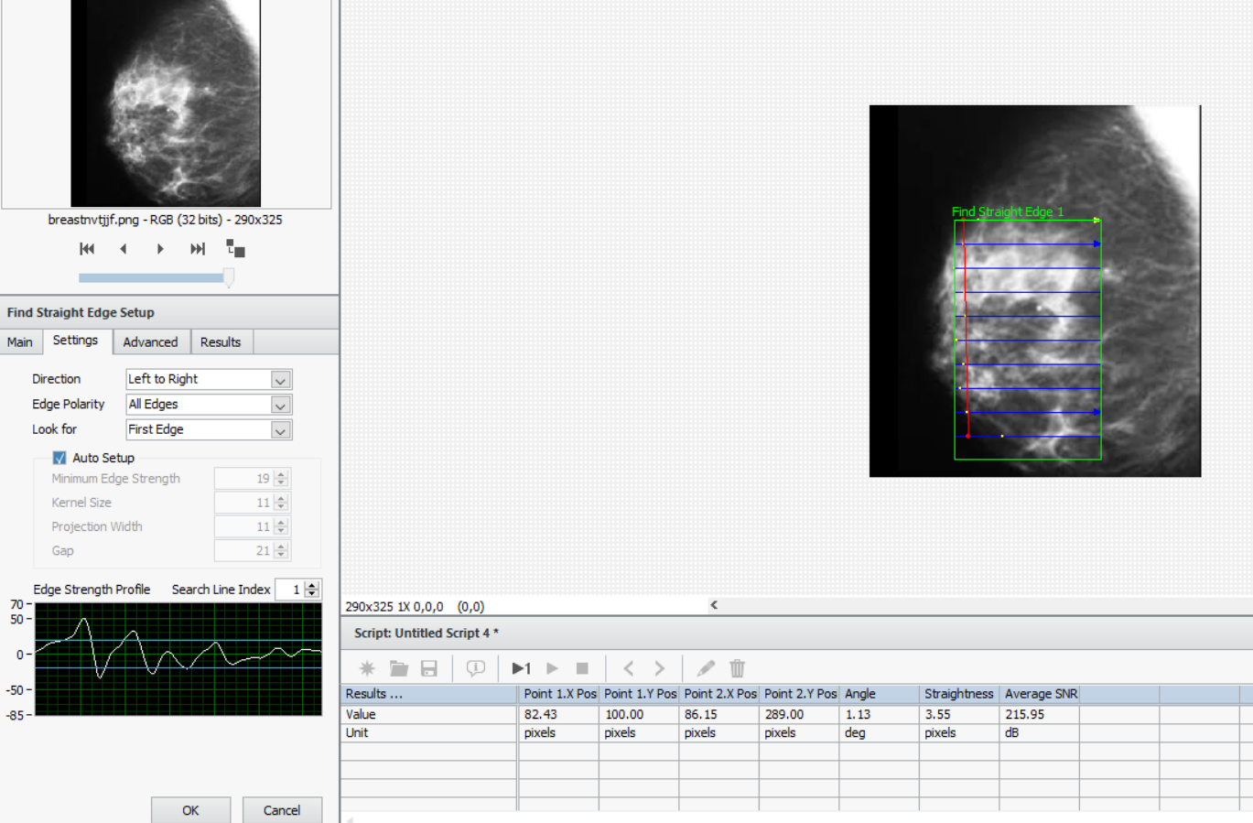

**FIG.17 Straight edge setup**

**CONCLUSION**

This paper aims to assess the tumor using NI Labview and Vision Assistant for the first time. In tumor detection research, one of the key methods is the brightness and contrast. With this technique, we were able to precisely identify the tumor from the mammography. According to the analysis of the data, the suggested approach produces results that are suitable for indicating the patient's state with breast cancer.

**REFERENCES**

1.DeSantis CE, Bray F, Ferlay J, Lortet-Tieulent J, Anderson BO, Jemal A. International Variation in Female Breast Cancer Incidence and Mortality Rates. Cancer Epidemiol Biomarkers Prev. 2015; 24(10): 1495-506.

2.Stoltenberg M, Spence D, Daubman BR, Greaves N, Edwards R, Bromfield B, et al. The central role of provider training in implementing resource-stratified guidelines for palliative care in low-income and middle-income countries: Lessons from the Jamaica Cancer Care and Research Institute in the Caribbean and Universidad Catolica in Latin America. Cancer. 2020; 126 Suppl 10: 2448-57.

3.Ginsburg O, Yip CH, Brooks A, Cabanes A, Caleffi M, Dunstan Yataco JA, et al. Breast cancer early detection: A phased approach to implementation. Cancer. 2020; 126 Suppl 10: 2379-93.

4.Mutebi M, Anderson BO, Duggan C, Adebamowo C, Agarwal G, Ali Z, et al. Breast cancer treatment: A phased approach to implementation. Cancer. 2020; 126 Suppl 10: 2365-78.

5.Velazquez Berumen A, Jimenez Moyao G, Rodriguez NM, Ilbawi AM, Migliore A, Shulman LN. Defining priority medical devices for cancer management: a WHO initiative. Lancet Oncol. 2018; 19(12): e709-e19.

6. Ilbawi AM, Velazquez-Berumen A. World Health Organization List of Priority Medical Devices for Cancer Management to Promote Universal Coverage. Clin Lab Med. 2018; 38(1): 151-60.

7.McCormack V, McKenzie F, Foerster M, Zietsman A, Galukande M, Adisa C, et al. Breast cancer survival and survival gap apportionment in sub-Saharan Africa (ABC-DO): a prospective cohort study. The Lancet Global health. 2020; 8(9): e1203-e12.

8. Rositch AF, Unger-Saldana K, DeBoer RJ, Ng'ang'a A, Weiner BJ. The role of dissemination and implementation science in global breast cancer control programs: Frameworks, methods, and examples. Cancer. 2020; 126 Suppl 10: 2394-404.

9.Wild CP, Weiderpass E, Stewart BW, editors (2020). World Cancer Report: Cancer Research for Cancer Prevention. Lyon, France: International Agency for Research on Cancer.